EBS Volumes and Operations Guide
This document provides a detailed overview of Amazon Elastic Block Store (EBS) volumes, their types, and step-by-step instructions for attaching volumes, creating partitions, and mounting them to EC2 instances.

EBS Volumes and Its Types
Amazon Elastic Block Store (EBS) provides persistent block storage for use with Amazon EC2 instances. These volumes are highly available, reliable, and scalable.
Types of EBS Volumes
- General Purpose SSD (gp3, gp2)
  - Ideal for a wide range of workloads, including boot volumes, dev/test environments, and low-latency interactive apps.
  - gp3 offers predictable IOPS and lower costs compared to gp2.
- Provisioned IOPS SSD (io1, io2)
  - Designed for I/O-intensive applications, such as databases.
  - Offers high durability and supports features like Multi-Attach.
Throughput Optimized HDD (st1)
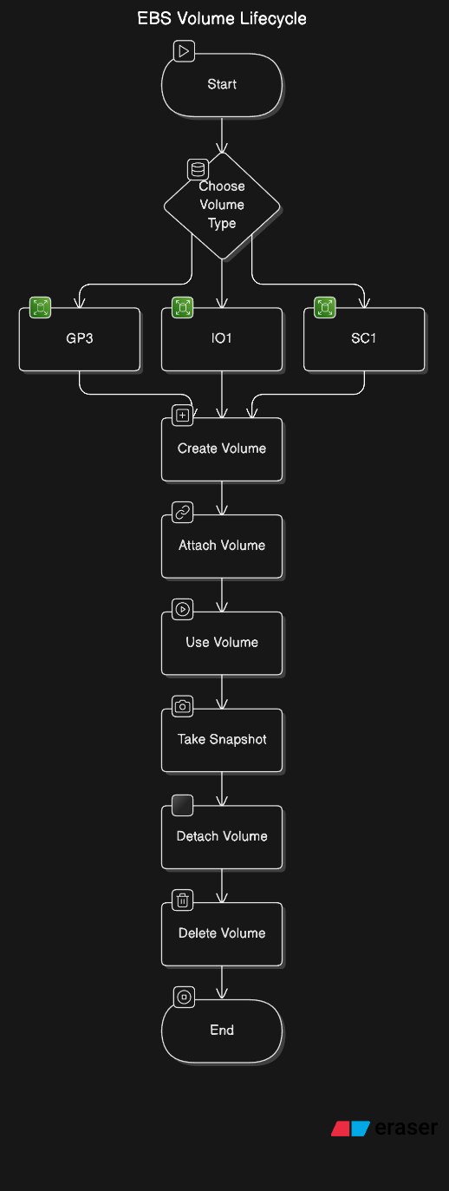
  - Suitable for frequently accessed, throughput-intensive workloads such as big data and log processing.
- Cold HDD (sc1)
  - Ideal for infrequently accessed workloads, such as backups and archiving.
- Magnetic (Standard)
  - Suitable for workloads where data is infrequently accessed.
Refer to AWS EBS Volume Types Documentation

Attach Volumes, Create Partition, and Mount
Attaching an EBS Volume to an EC2 Instance
- Go to the EC2 Dashboard on the AWS Management Console.
- Select Volumes from the left menu.
- Choose the volume you want to attach and click Actions > Attach Volume.
- Select the instance to attach the volume to and click Attach.
Creating a Partition
- SSH into the EC2 instance to which the volume was attached.
- Use the lsblk command to list all block devices and confirm the new volume is attached (e.g., /dev/xvdf).
- Create a partition on the volume using the fdisk command:
sudo fdisk /dev/xvdf
  - Press n to create a new partition.
  - Follow the prompts and press w to write changes.
- Format the partition:
sudo mkfs.ext4 /dev/xvdf1
Mounting the Volume
- Create a mount directory:
sudo mkdir /mnt/ebs-volume
- Mount the volume:
sudo mount /dev/xvdf1 /mnt/ebs-volume
- Verify the volume is mounted:
df -h
Persisting the Mount (Optional)
To make the mount persistent across reboots:
- Open the /etc/fstab file:
sudo nano /etc/fstab
- Add the following entry:
/dev/xvdf1 /mnt/ebs-volume ext4 defaults,nofail 0 2
- Save the file and exit.
- Test the configuration:
sudo mount -a

Summary
- EBS Volumes: Provide persistent, reliable block storage.
- Volume Types: Include SSDs (gp3, gp2, io1, io2), HDDs (st1, sc1), and magnetic storage.
- Operations: Attach a volume, create partitions, format, and mount it to an EC2 instance.

EBS Snapshot and Partition Management Guide
This document provides detailed instructions for managing partitions, configuring permanent mounts, taking EBS backups using snapshots, and automating the snapshot process through policies.

Partitions and Permanent Mount
Creating a Partition
- List available block devices:
lsblk
- Select the device to partition (e.g., /dev/xvdf) and run the fdisk command:
sudo fdisk /dev/xvdf
  - Press n to create a new partition.
  - Follow the prompts to define partition size.
  - Press w to write changes and exit.
- Format the partition:
sudo mkfs.ext4 /dev/xvdf1
Mounting the Partition
- Create a directory to mount the partition:
sudo mkdir /mnt/data
- Mount the partition:
sudo mount /dev/xvdf1 /mnt/data
- Verify the mount:
df -h
Making the Mount Permanent
To ensure the partition mounts automatically on reboot:
- Retrieve the UUID of the device:
sudo blkid
Example output:
/dev/xvdf1: UUID="abcd-1234" TYPE="ext4"
- Edit the /etc/fstab file:
sudo nano /etc/fstab
- Add the following line:
- UUID=abcd-1234 /mnt/data ext4 defaults,nofail 0 2
- Test the configuration:
sudo mount -a

Taking Backup Using Snapshots
Manual Snapshot Creation
- Navigate to the EC2 Dashboard on the AWS Management Console.
- Select Volumes from the left-hand menu.
- Choose the volume to back up and click Actions > Create Snapshot.
- Provide a description for the snapshot and click Create Snapshot.
- To view snapshots, navigate to Snapshots in the EC2 Dashboard.
Snapshot via CLI
- Use the following command to create a snapshot:
aws ec2 create-snapshot --volume-id vol-0123456789abcdef0 --description "My Snapshot"
- Verify the snapshot:
aws ec2 describe-snapshots --snapshot-ids snap-0123456789abcdef0

Automating Snapshots Using Snapshot Policies
Create a Snapshot Lifecycle Policy
- Navigate to the Amazon Data Lifecycle Manager (DLM) in the AWS Management Console.
- Click Create lifecycle policy.
- Select EBS Snapshot policy.
- Configure policy details:
  - Select resource type as Volume.
  - Add tags to identify the volumes to be included in the policy (e.g., Environment:Production).
- Define a schedule:
  - Specify the frequency of snapshots (e.g., daily).
  - Define a retention period (e.g., retain snapshots for 7 days).
- Review and create the policy.
Automating Snapshots via AWS CLI
- Create a policy JSON file (snapshot-policy.json):
{
"ResourceType": "VOLUME",
"TargetTags": [
{
"Key": "Environment",
"Value": "Production"
}
],
"Schedules": [
{
"Name": "DailySnapshot",
"Frequency": "24",
"RetentionPeriod": "7"
}
]
}
Create the lifecycle policy:
aws dlm create-lifecycle-policy --policy-details file://snapshot-policy.json
Verify the policy:
aws dlm get-lifecycle-policies

Summary
- Partition Management: Create and persist partitions using fstab.
- Snapshots: Manual and CLI-based snapshot creation.
- Automation: Implement lifecycle policies for scheduled backups.

